**Manav Rachna International Institute of Research and Studies (MRIIRS)**

**School of Computer Applications**

Data Structures using C



**Name**: Armaan Haider

**Roll No**: 24/SCA/BCA/059

**Semester**: 2nd

**Section**: B

**Course**: Bachelor's in Computer Applications (BCA)

# Array

An **array** is a linear data structure that stores data of similar types under a single name in a contiguous memory location.

**// 1. Program to demonstrate insertion and output in an array:**

#include <stdio.h> int main(){

int arr[5];

**//Array Insertion.**

printf("Enter the elements in array: \n"); for(int i = 0; i<5; i++){ scanf("%d", &arr[i]);

}

**//Output from an array.**  printf("\n The elements that you have enterd are: "); for(int i = 0; i<5; i++){ printf("%d ", arr[i]);

}

return 0;

}

**Output:**

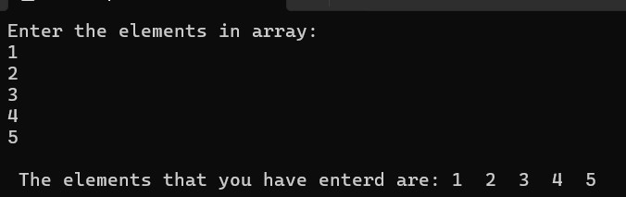

**// 2. Program to demonstrate searching in an array:**

#include <stdio.h>

int main() { int arr[] = {10, 20, 30, 40, 50}; int size = sizeof(arr) / sizeof(arr[0]); int key, found = 0;

printf("Enter the element to search: "); scanf("%d", &key);

for (int i = 0; i < size; i++) { if (arr[i] == key) { printf("Element %d found at index %d.\n", key, i); found = 1; break;

}

}

if (found == 0) { printf("Element %d not found in the array.\n", key);

}

return 0;

}

**Output:**

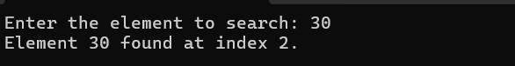

**// 3. Program to demonstrate sorting in an array:**

#include <stdio.h> int main(){ int arr[5] = {1,7,3,6,4}; int temp; for(int i = 0; i<5; i++){ for(int j = 0; j<4; j++){ if(arr[j] > arr[j + 1]){ temp = arr[j]; arr[j] = arr[j + 1]; arr[j + 1] = temp;

}

}

}

printf("Ascending order: \n"); for(int i = 0; i<5; i++){ printf("%d ", arr[i]);

}

}

**Output:**

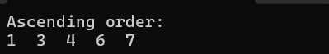

# Stacks

Stack is a linear data structure that follows the LIFO (Last –In-First-Out) method. It means that the last data element to be inserted in the stack will be the first to come out.

There are two **operations on Stack**. They are:

1. **Push**: It is used to insert an element into the stack.
2. **Pop**: It is used to remove an element from the stack.

**// 1. Program to demonstrate PUSH() and POP() operations in the stack:**

#include<stdio.h>

#define Max 5 **//Max size of the stack.**

**//Structure of the stack.**

struct Stack{ int data[Max]; int top;

}; struct Stack s; **//Initializing the stack.**

**//Declaring Functions** void PUSH(int n); void POP(); void PRINT();

**//Program execution starts from here.**

int main(){

s.top = -1;

POP();

PUSH(10);

PUSH(20);

PUSH(30);

PUSH(40);

PUSH(50);

PUSH(60);

POP(); PRINT();

return 0;

}

**// 1.1. Function to insert an element into the stack.**

void PUSH(int n){ if(s.top == Max-1){ printf("Stack is full.\n\n"); return; }

s.data[++s.top] = n; printf("%d pushed into the stack\n\n", n);

}

**// 1.2. Function to remove an element from the stack.**

void POP(){ if(s.top == -1){ printf("Stack is empty\n\n"); return; } int value = s.data[s.top--]; printf("%d removed from the stack\n\n", value);

}

**// 1.3. Function to traverse and print all the elements in the stack.**

void PRINT(){ if(s.top == -1){ printf("Stack is empty\n\n"); return; } printf("Elements in the stack:\n"); for(int i=0; i<=s.top; i++){ printf("%d\t", s.data[i]); if(i==s.top){ printf("\n\n");

}

}

}

**Output:**

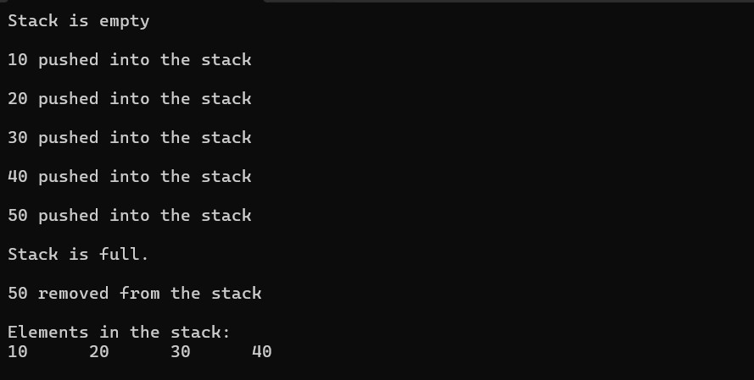

# Queue

A **queue** is a linear data structure that stores data in **FIFO** (First-In-First-Out) order. It means that the first element to be inserted in the queue will also be the first element to come out.

The **operations we can perform on a queue** are:

1. **Enqueue**: To insert an element in the queue.
2. **Dequeue**: To remove an element from the queue.

**// 1. Program to demonstrate ENQUEUE () and DEQUEUE () operations in a queue:**

#include<stdio.h>

#define Max 5

**//Structure of a queue.**

struct Queue{ int data[Max]; int front; int rear; }; struct Queue q; **//Initializing a queue.**

**//Declaring functions.** void ENQUEUE(int n); void DEQUEUE(); void PRINT();

**//Program execution starts from here.**

int main(){

q.front = -1;

q.rear = -1;

DEQUEUE();

ENQUEUE(10);

ENQUEUE(20);

ENQUEUE(30);

ENQUEUE(40);

ENQUEUE(50);

ENQUEUE(60);

DEQUEUE(); PRINT();

return 0;

}

**// 1.1 Function to insert an element in the queue.**

void ENQUEUE(int n){ if(q.rear == Max-1){ printf("Queue is full\n\n"); return; }

q.data[++q.rear] = n; printf("%d inserted in the queue\n\n", n);

}

**// 1.2. Function to remove an element from a queue.**

void DEQUEUE(){

if(q.rear == q.front){ printf("Queue is empty\n\n");

q.front = -1;

q.rear = -1; return;

}

int value = q.data[++q.front]; printf("%d removed from the queue\n\n", value);

}

**// 1.3. Function to traverse and display all the elements in the queue.**

void PRINT(){ if(q.front == q.rear){ printf("Queue is empty\n\n"); return; } for(int i=q.front+1; i<=q.rear; i++){ printf("%d\t", q.data[i]); if(i==q.rear){ printf("\n\n");

}

}

}

**Output:**

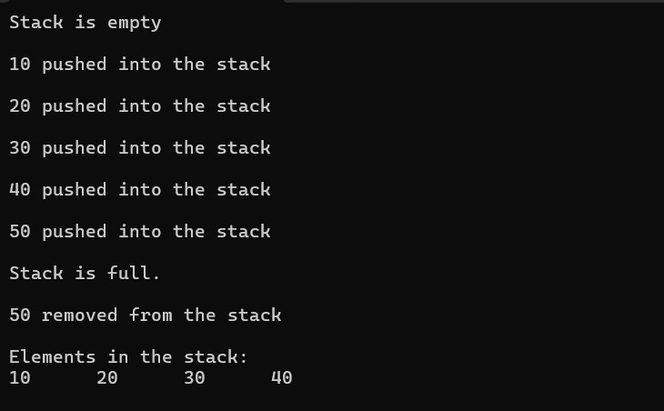

**Circular Queue**

A **circular queue** is a type of queue in which the last element of the queue is connected to the first element of the queue, making a circular chain.

**// 1. Program to implement circular queue and operations on it.**

#include <stdio.h>

#define MAX 5

struct Queue { int data[MAX];

int front; int rear;

};

struct Queue q = {.front = -1, .rear = -1};

**// 1.1. Function to insert element into the circular queue** void ENQUEUE(int value) { if ((q.rear + 1) % MAX == q.front) { printf("Queue is full\n"); return;

}

if (q.front == -1) {

q.front = 0;

}

q.rear = (q.rear + 1) % MAX;

q.data[q.rear] = value;

printf("%d inserted into the queue\n", value);

}

**// 1.2. Function to remove element from the circular queue** void DEQUEUE() {

if (q.front == -1) { printf("Queue is empty\n"); return;

}

int value = q.data[q.front];

if (q.front == q.rear) {  **// Only one element in queue**

q.front = -1;

q.rear = -1;

} else {

q.front = (q.front + 1) % MAX;

}

printf("%d removed from the queue\n", value);

}

**// 1.3. Function to display the elements of the queue** void DISPLAY() {

if (q.front == -1) { printf("Queue is empty\n"); return;

}

printf("Queue elements: "); int i = q.front; while (1) { printf("%d ", q.data[i]); if (i == q.rear) break; i = (i + 1) % MAX;

} printf("\n");

}

**// Main function to test the queue** int main() {

ENQUEUE(10);

ENQUEUE(20);

ENQUEUE(30);

ENQUEUE(40);

ENQUEUE(50); **// Will say "Queue is full" because one slot is always kept empty.**

DISPLAY();

DEQUEUE();

DEQUEUE();

DISPLAY();

ENQUEUE(60);

ENQUEUE(70); DISPLAY();

return 0;

}

**Output:**

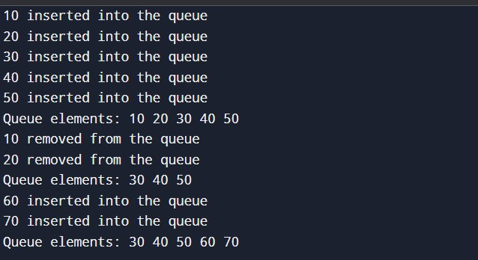

# Linked List

A **linked list** is a linear data structure that uses nodes to store the data, and each node is connected to another node via pointers.

We can perform various operations on a linked list such as:

1. Insertion at beginning.
2. Insertion at end. iii. Insertion at specific position. iv. Deletion from beginning. v. Deletion form end. vi. Deletion from a specific position.

**// 1. Program to show the implementation of a linked list and its operations.**

#include<stdio.h>

#include<stdlib.h>

**//Structure of a Node.**

struct Node{

int data; struct Node* next;

};

**//Declaring functions.**

void insertAtBeginning(Node** pointerToHead, int x); void insertAtEnd(Node** pointerToHead, int x); void insertAt(Node** pointerToHead, int pos, int x); void deleteFromFirst(Node** pointerToHead); void deleteFromEnd(Node** pointerToHead); void deleteFrom(Node** pointerToHead, int pos); void Print(Node* head);

**//Execution of program starts from here.**

int main(){ struct Node* head = NULL; insertAtEnd(&head, 20); insertAtBeginning(&head, 10); insertAtBeginning(&head, 30); insertAt(&head, 1, 70); insertAt(&head, 4, 80); insertAt(&head, 5, 90); insertAtEnd(&head, 100); deleteFrom(&head, 1); deleteFrom(&head, 4); deleteFrom(&head, 5); deleteFromFirst(&head); deleteFromEnd(&head);

Reverse(&head);

Print(head);

}

**// 1.1. Insert a node at the beginning.**

void insertAtBeginning(Node** pointerToHead, int x){ struct Node* newNode = (struct Node*)malloc(sizeof(struct Node)); newNode -> data = x; newNode -> next = *pointerToHead;

*pointerToHead = newNode;

}

**// 1.2. Insert a node at the end.**

void insertAtEnd(Node** pointerToHead, int x){ struct Node* newNode = (struct Node*) malloc(sizeof(struct Node)); newNode -> data = x; newNode -> next = NULL;

if(*pointerToHead == NULL){ *pointerToHead = newNode;

} else{ struct Node* endNode = *pointerToHead; while(endNode -> next != NULL){ endNode = endNode -> next;

}

endNode -> next = newNode;

}

}

**// 1.3. Insert a node at nth position.**

void insertAt(Node** pointerToHead, int pos, int x){

if(pos<1){ printf("Invalid Position\n"); return;

}

struct Node* newNode = (struct Node*)malloc(sizeof(struct Node)); newNode -> data = x;

if(pos == 1){ newNode -> next = *pointerToHead;

*pointerToHead = newNode;

return;

}

struct Node* current = *pointerToHead;

for(int i=1; i<pos-1 && current!=NULL; i++){ current = current -> next;

}

if(current == NULL){ printf("Invlalid position\n"); free(newNode); return;

}

newNode -> next = current -> next; current -> next = newNode;

}

**// 1.4. Delete a node from nth position.** void deleteFrom(Node** pointerToHead, int pos){ if(*pointerToHead == NULL || pos<1){ printf("Invalid position or empty list\n"); return;

}

if(pos == 1){

Node* temp = *pointerToHead;

*pointerToHead = (*pointerToHead)-> next; free(temp); return;

}

Node* current = *pointerToHead;

for(int i=1; i<pos-1 && current != NULL; i++){ current = current -> next;

}

if(current == NULL || current -> next == NULL){

printf("Invalid position\n"); return;

}

Node* temp = current -> next; current -> next = current -> next -> next; free(temp);

}

**// 1.5. Delete a node from first position.** void deleteFromFirst(Node** pointerToHead){ if(*pointerToHead == NULL){ printf("List is empty\n"); return;

}

Node* temp = *pointerToHead; *pointerToHead = (*pointerToHead) -> next; free(temp);

}

**// 1.6. Delete a node from the end.** void deleteFromEnd(Node** pointerToHead){ if(*pointerToHead == NULL){ printf("List is empty\n"); return;

}

if((*pointerToHead)-> next == NULL){

*pointerToHead = NULL;

return;

}

Node* endNode = *pointerToHead; while(endNode -> next -> next != NULL){ endNode = endNode -> next;

}

Node* temp = endNode -> next; endNode -> next = NULL; free(temp);

}

**// 1.7. Print the list.** void Print(Node* head){ while(head != NULL){ printf("%d\t", head -> data); head = head -> next;

} printf("\n");

}

**Output:**

